Зробив

Зробив Трощинський Ярослав

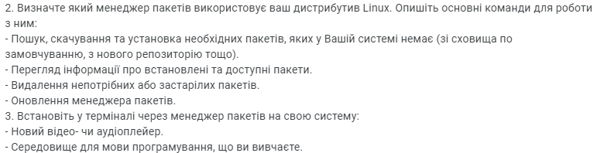

2. Determine which package manager uses your Linux distribution. Describe the main commands to work with it:

- search, download and install the necessary packages that are not in your system (from the default repository, from a new repository, etc.).

- View information about installed and available packages.

- Removal of unnecessary or outdated packages.

- Upgrade the package manager.

3. Set in the terminal through the package manager on your system:

- New video or audio player.

- the programming language environment you are studying.

2.

* I have a Ubuntu distribution, so my package manager is apt or dpkg, so I tried apt and dpkg commands in terminal, and got this results

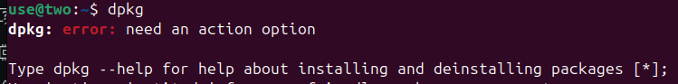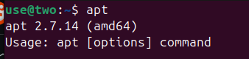

From this results I can say that I have a apt manager

* If you type in terminal apt it will give you a version of package manager and list of most used commands

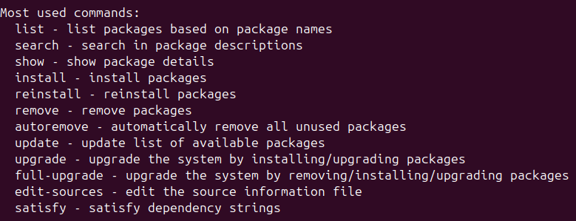

* To find needed package you can use a command

apt list *keyword*

And if your search list is too big you can send this list in the ,txt file via

cd *your_directory*

apt list *keyword*>*name_of_txt_file*

To download found package you can use a command

sudo apt install *package_name*

And it will be downloaded and after this automatically installed

* To see installed packages we can use a command

apt list --installed

* And to remove package we can use a command

sudo apt remove *package_name*

To remove unused packages we can use a command

sudo apt autoremove

To update all packages we can use a command

sudo apt update

* To upgrade package manager we can use a command

sudo apt upgrade

3.

* I chose a VLC media player, to install it we can use a command

sudo apt install vlc

* To download C++ environment I chose to download a Visual Studio Code. For this I`ll need to firstly download .deb file from the official site of VSCode, and then we need to use this command

sudo apt install Downloads/code*

After installing we can see VSCode in “Show apps” menu

